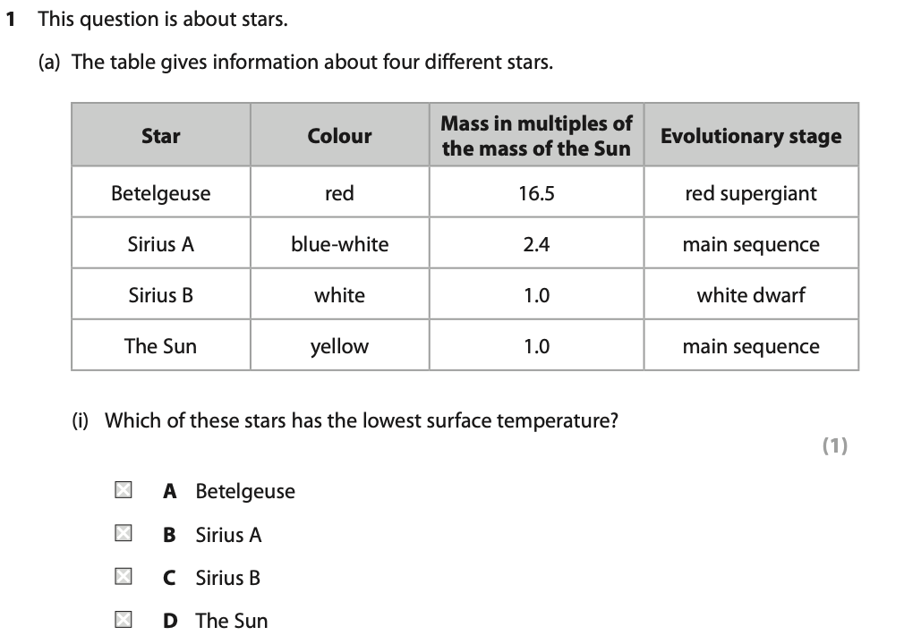
Answer_______
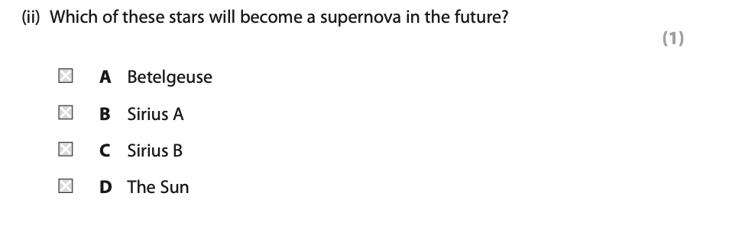
Answer_______

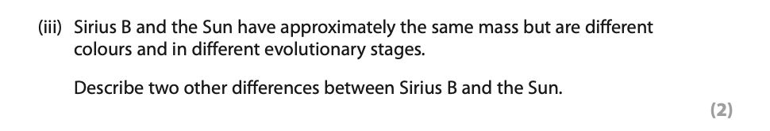
Answer_____________________________________________________________________________________________________________________________________________________________________________________________________________________
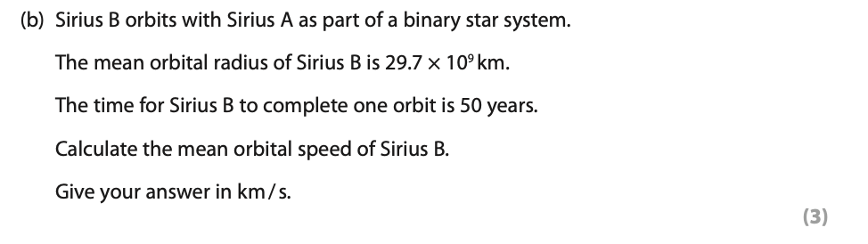
Answer_____________________________________________________________________________________________________________________________________________________________________________________________________________________

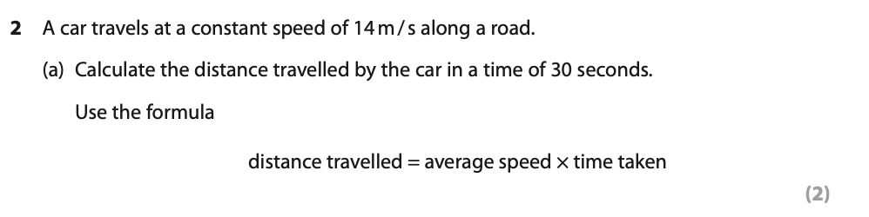
Answer_____________________________________________________________________________________________________________________________________________________________________________________________________________________

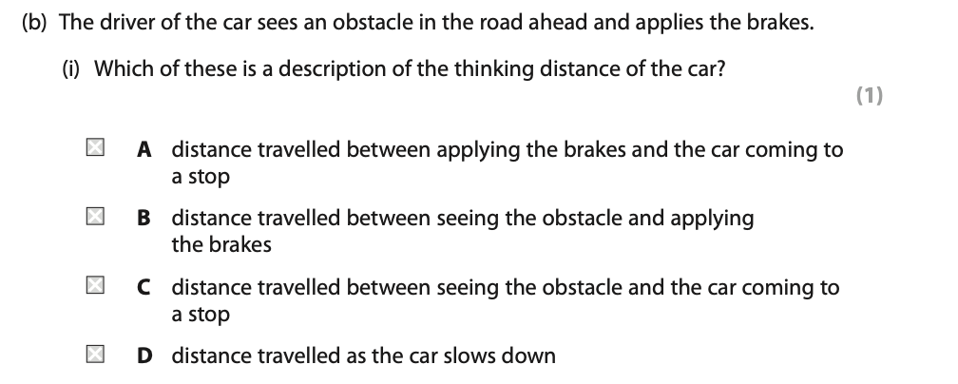
Answer_______
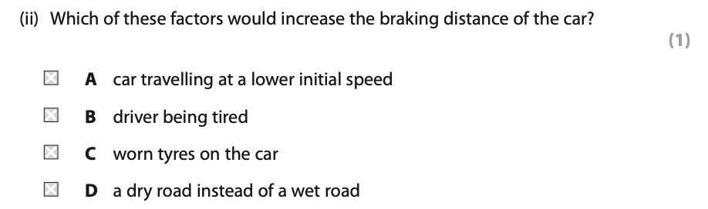
Answer______

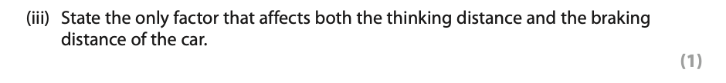
Answer_____________________________________________________________________________________________________________________________________________________________________________________________________________________

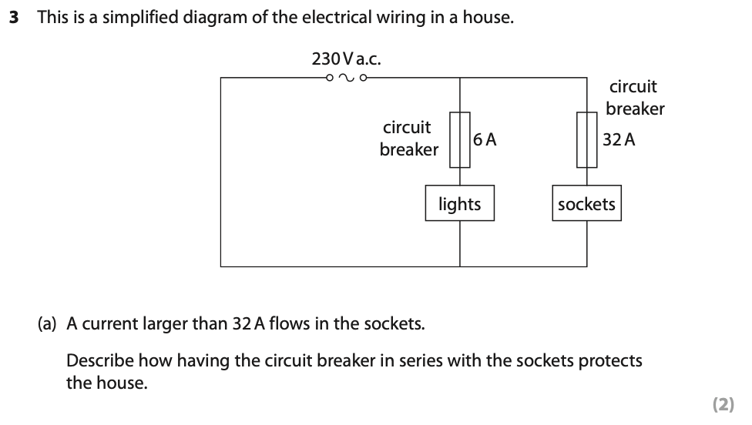
Answer_____________________________________________________________________________________________________________________________________________________________________________________________________________________
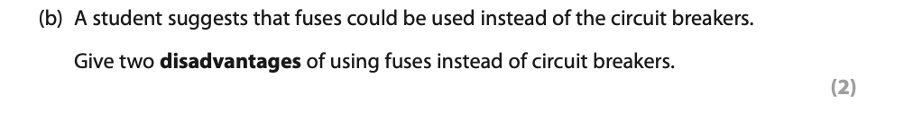
Answer_____________________________________________________________________________________________________________________________________________________________________________________________________________________
_________________________________________________________________________
Answer_____________________________________________________________________________________________________________________________________________________________________________________________________________________
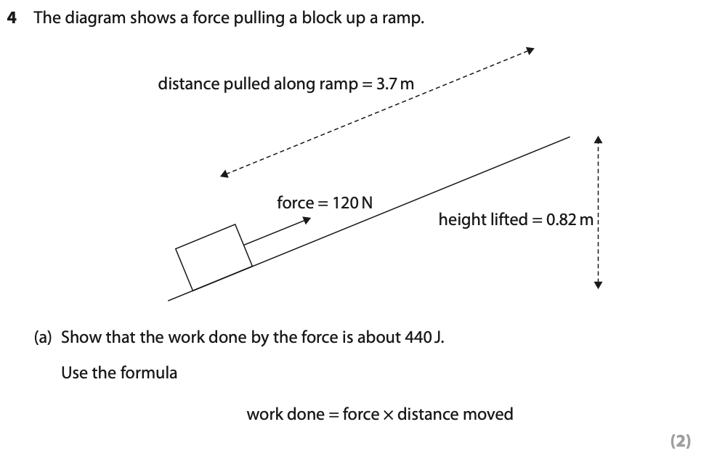
Answer_____________________________________________________________________________________________________________________________________________________________________________________________________________________
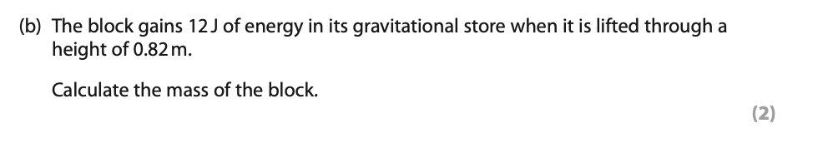
Answer_____________________________________________________________________________________________________________________________________________________________________________________________________________________
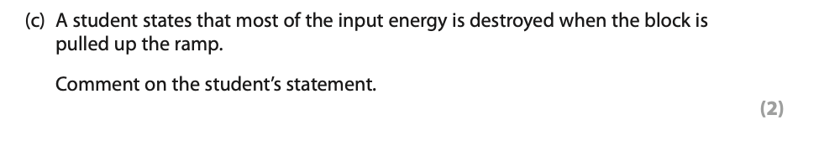
Answer_____________________________________________________________________________________________________________________________________________________________________________________________________________________
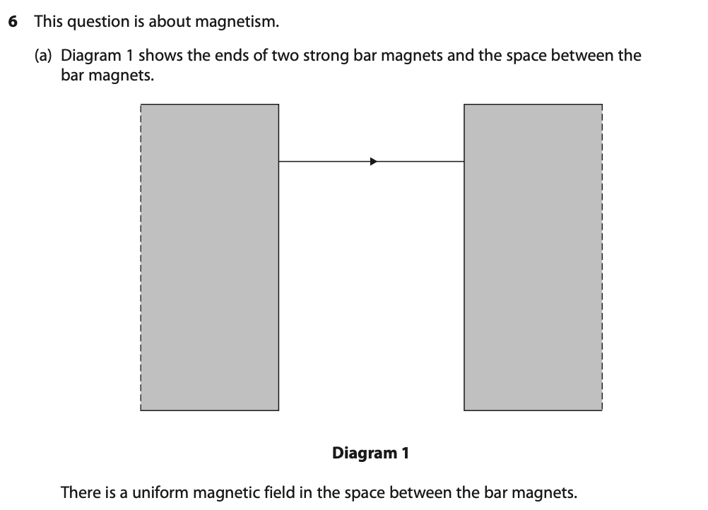
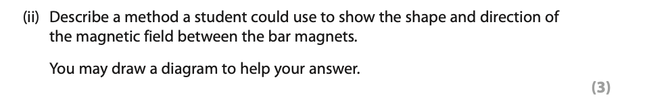
Answer_____________________________________________________________________________________________________________________________________________________________________________________________________________________
Answer_____________________________________________________________________________________________________________________________________________________________________________________________________________________
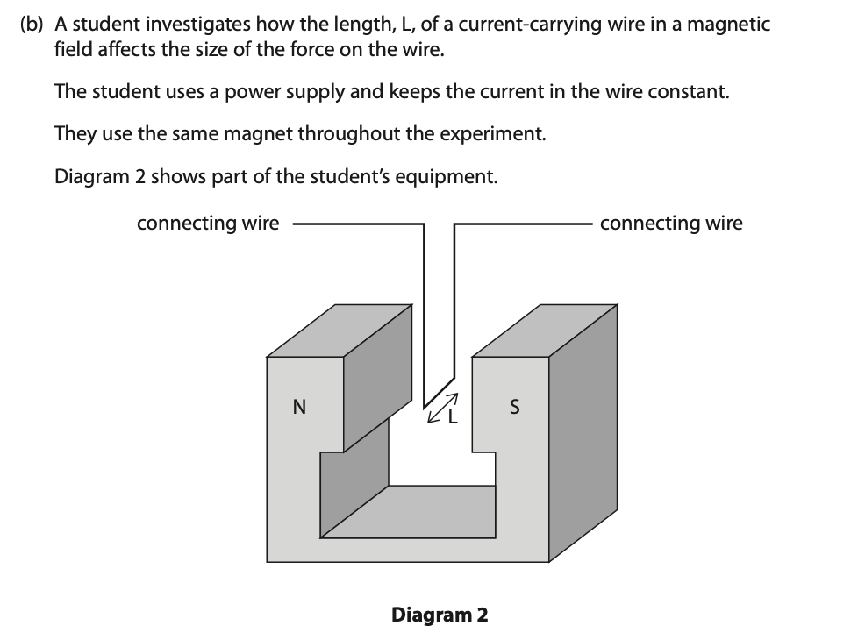
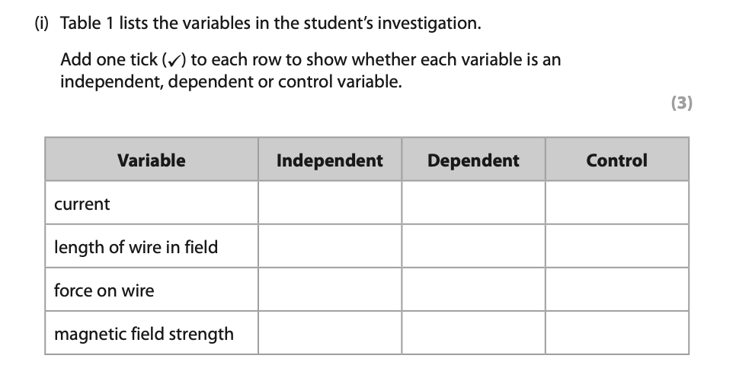
Answer_____________________________________________________________________________________________________________________________________________________________________________________________________________________
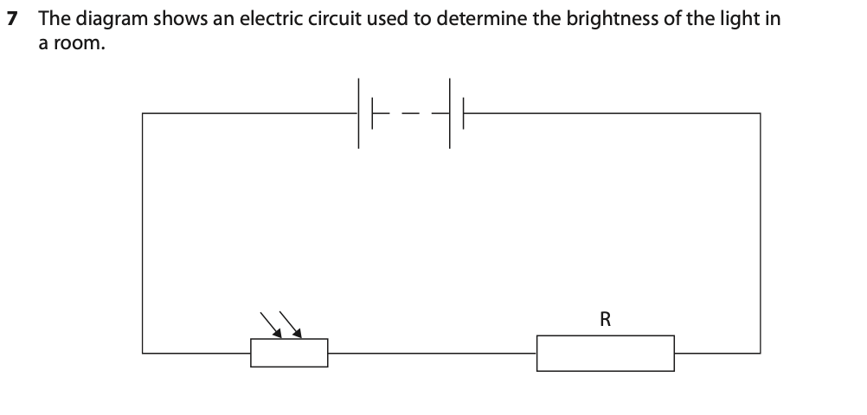
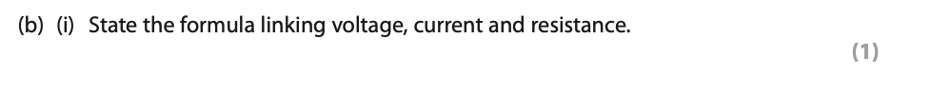
Answer_____________________________________________________________________________________________________________________________________________________________________________________________________________________

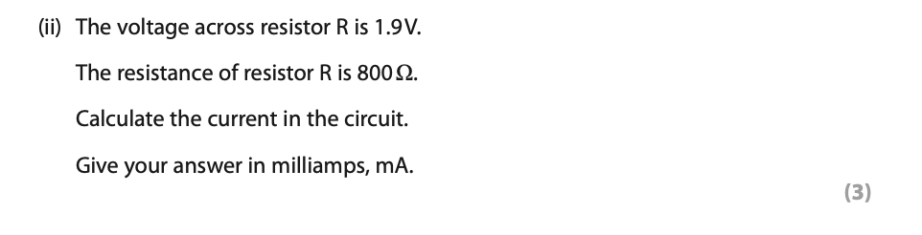
Answer_____________________________________________________________________________________________________________________________________________________________________________________________________________________
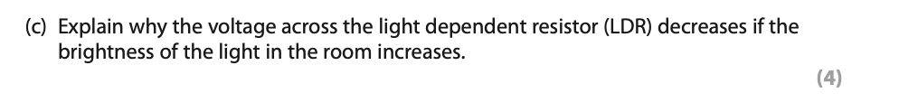
Answer_____________________________________________________________________________________________________________________________________________________________________________________________________________________
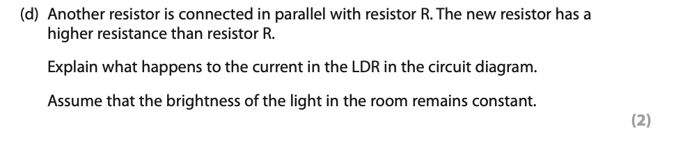
Answer_____________________________________________________________________________________________________________________________________________________________________________________________________________________
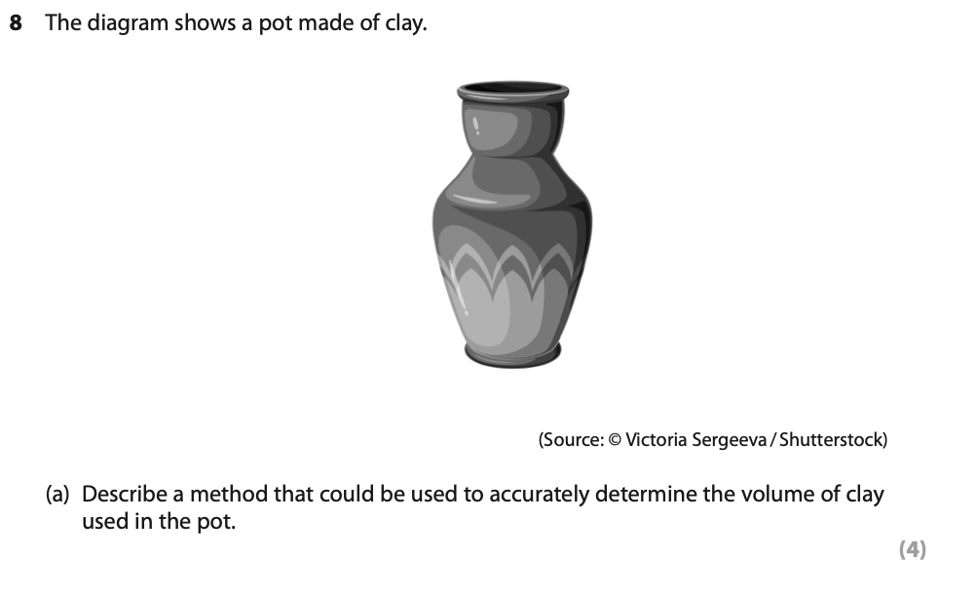
Answer_______________________________________________________________________________________________________________________________________________________________________________________________________________________________________________________________________________________________________________________________________________________________________

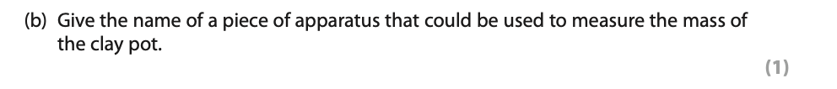
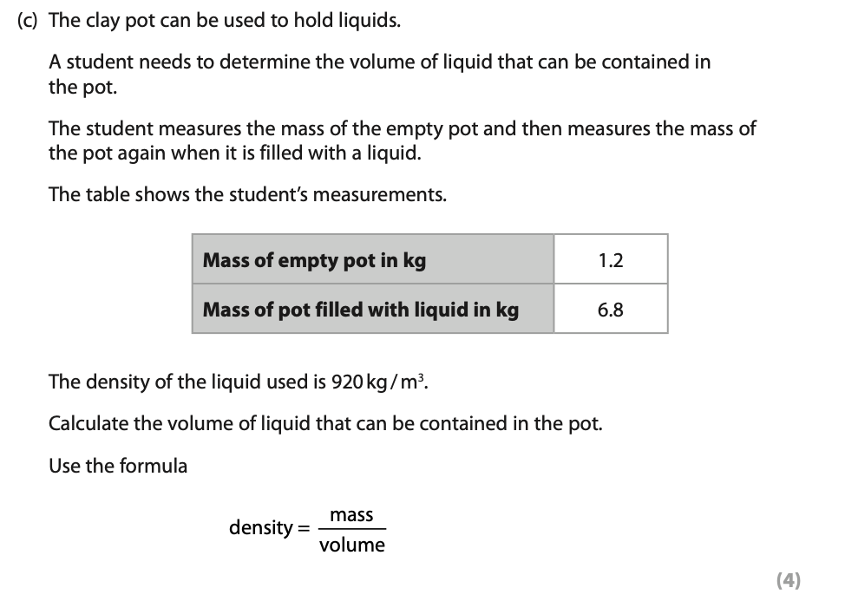
Answer_____________________________________________________________________________________________________________________________________________________________________________________________________________________
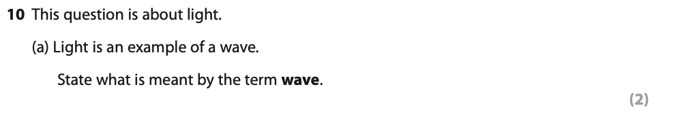
Answer_____________________________________________________________________________________________________________________________________________________________________________________________________________________
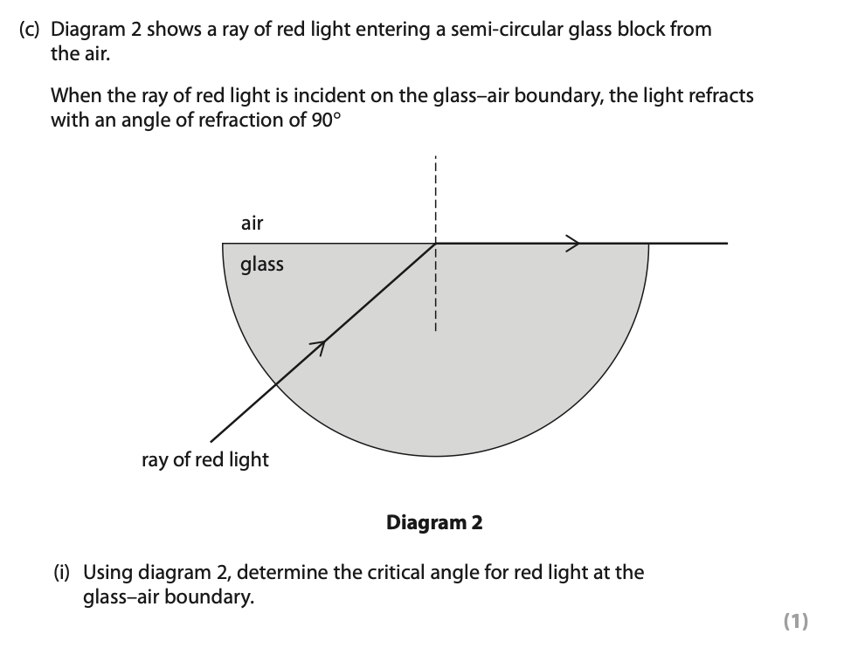
Answer_____________________________________________________________________________________________________________________________________________________________________________________________________________________
Answer_____________________________________________________________________________________________________________________________________________________________________________________________________________________
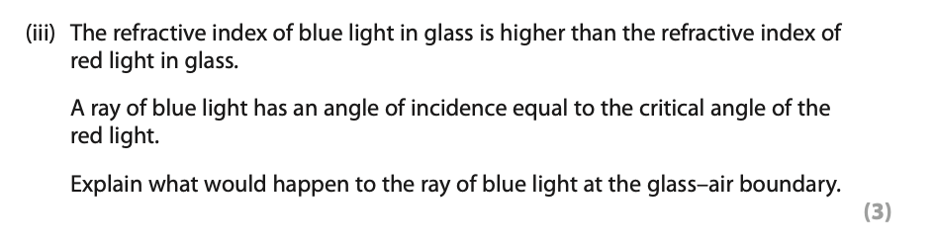
Answer_____________________________________________________________________________________________________________________________________________________________________________________________________________________
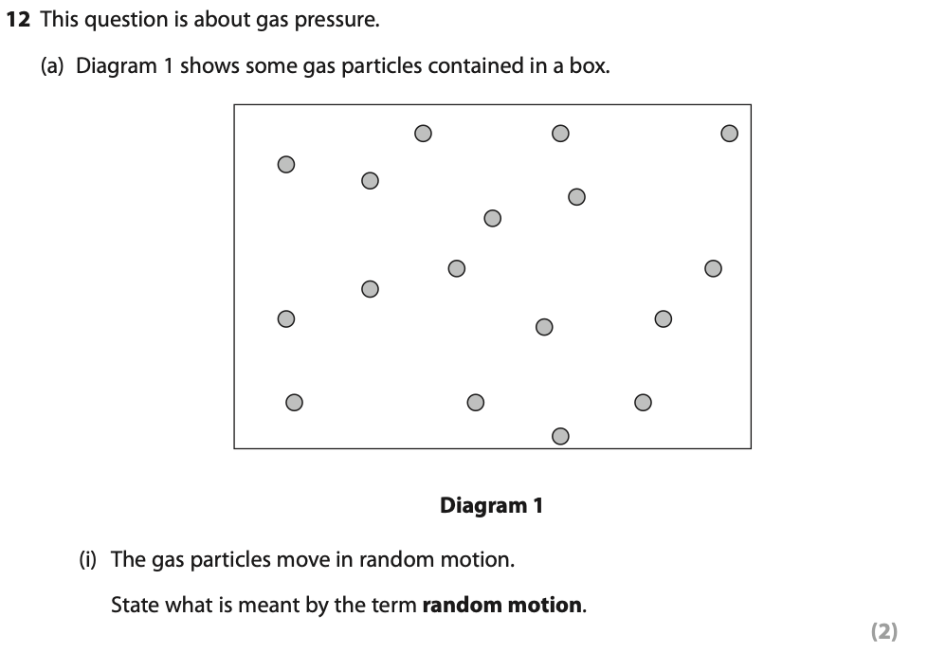
Answer_____________________________________________________________________________________________________________________________________________________________________________________________________________________

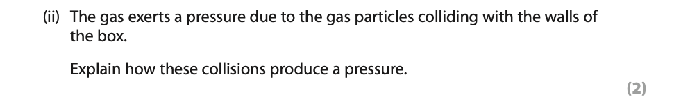
Answer_____________________________________________________________________________________________________________________________________________________________________________________________________________________
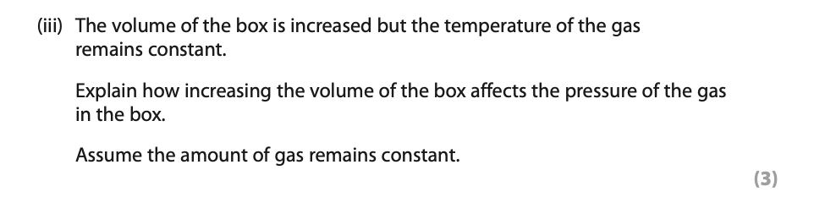
Answer_____________________________________________________________________________________________________________________________________________________________________________________________________________________

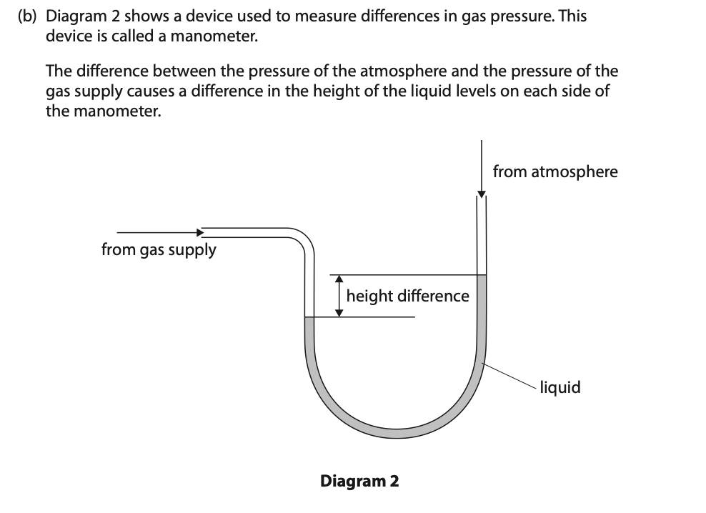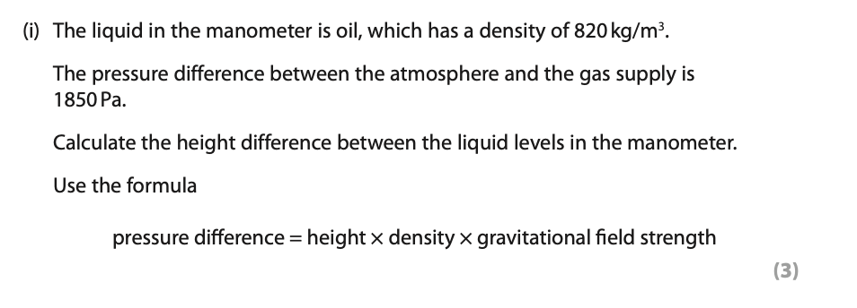
Answer_____________________________________________________________________________________________________________________________________________________________________________________________________________________
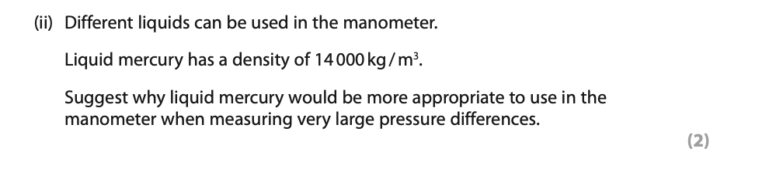
Answer_____________________________________________________________________________________________________________________________________________________________________________________________________________________
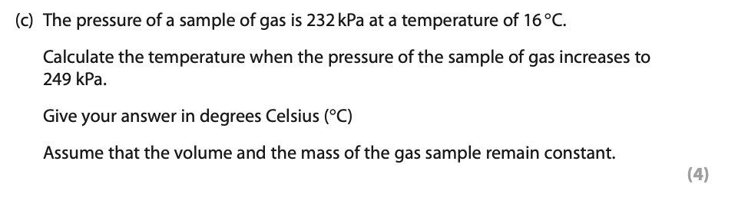
Answer_____________________________________________________________________________________________________________________________________________________________________________________________________________________

